# **20141021 - 4 CH 315M RF Wireless Remote Control Controller w/case**

(now in stock) [Instructions for 4 CH Wireless Remote](http://mc003.en.alibaba.com/product/1851060882-218231507/YET_404PC_wireless_receiving_control_device_appiy_to_curtain_gate_auto_.html)

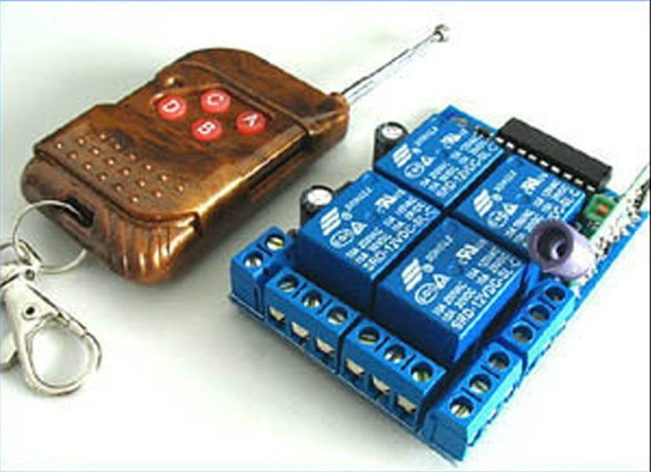

## Specifications

high anti-interfence 4 channel wireless receiving control :

1.power consume and very convenience.

2.CE&ROHS

3.OEM

4 channel wireless intellect receiving control

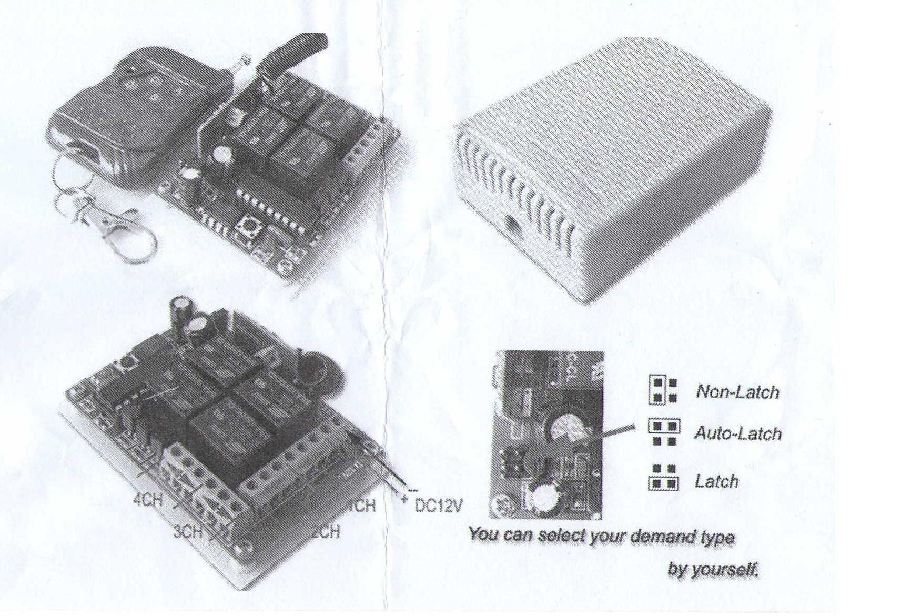

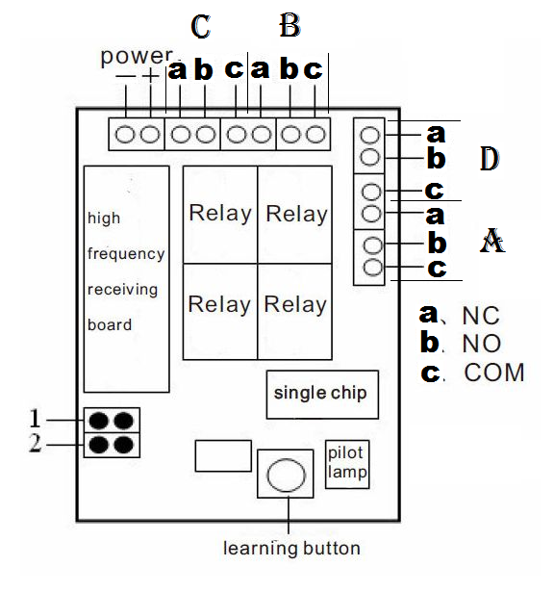

This kind of wireless intellect receiving control main apply to auto door, curtain, lifting appliance, gate way, lifter, industrial control and security field.

This kind of wireless receiving control is high confidentiality, large memory space, stable characteristics, low power consume and very convenience, it is unnecessary adopt the traditional wire jumper or dip switch code but only receive and store the wireless signal from the remote control, and The lost learnt control can not work if you delete the memory message of the receiving control, however, it should learning again by the owner if want to obtain the right of use.

The way of output

A. Signal self-locking-- “1” connect

B. Signal interlock-- “2” connect

C. Signal point start--disconnect

D. Two channel self-locking and another two channel point start--“1” and “2” both connect

(check the Circuit diagram for details)

Learning way and steps

Learning fixed code & learning code:

1. Press learning key of receiver—the pilot lamp light—release learning key and pilot lamp extinguish , indicate enter into the status of learning.

2. Press any button of the remote control, indicate learning success as the pilot lamp flash 5 times and automatically exitlearningstate. Receiverautomatically exitlearningstate if you do nothing in 32 seconds. (Can store up to 30pcs this type remote control)

Learning rolling code:

1. Press learning key of receiver—the pilot lamp light—release learning key and pilot lamp extinguish , indicate enter into the status of learning first time.
2. Press any button of the remote control, indicate first time learning success as the pilot lamp keep flashing slowly.
3. Repeat the operation of step “1”, enter into the status of learning second time.
4. Press the same button in step “2”, the pilot lamp flash 5 times, learning successful.(Can store up to 6pcs this type remote control)

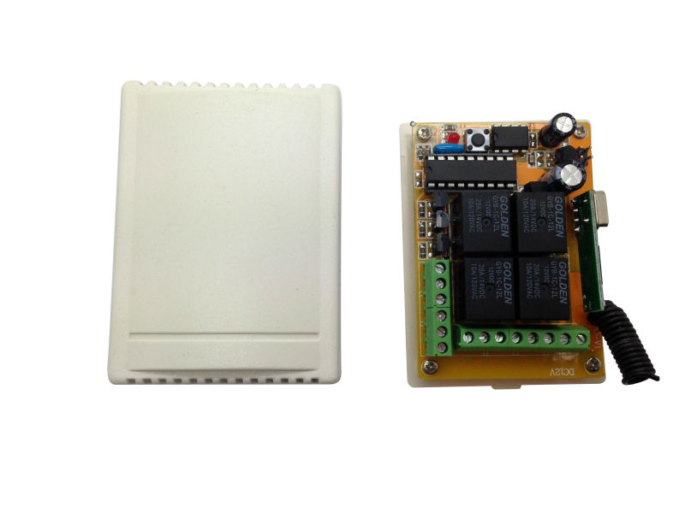

**Main Functions**

**Garage door control, lighting control, remote control curtains, household appliances wireless control switch, etc.**

**Specifications:**

|  |  |
| --- | --- |
| **Description** | **4 ways** |
| **Operating voltage** | **DC 12V** |
| **Quiescent Current** | **≤5 mA ~ ≤7 mA** |
| **Electronic Contact Capacity** | **7A 240V AC / 10A 24V DC** |
| **Transmitting Distance** | **150M ~ 200M (open place)** |
| **The way modify coding type** | **Bonding Pad** |
| **Operating Frequency** | **315MHz** |
| **Control Mode** | **Latch type, Non-latch type or Auto-latch type** |
| **Rated Load** | **2000 W** |
| **Dimension** | **88* 63 mm** |

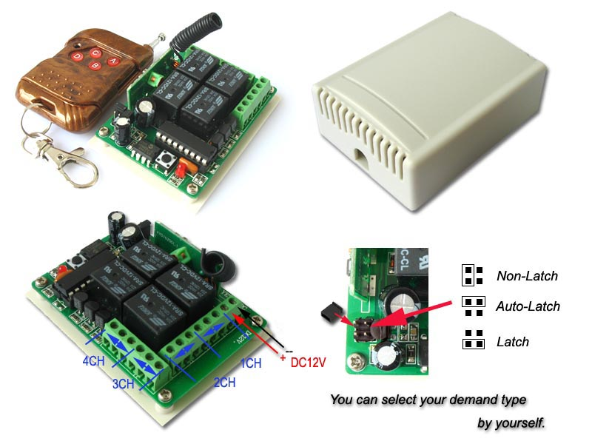

**Latch type: Press the button, the relay on till you press another one. Just like the wind-speed buttons of electronic-fan, press a wind-speed button, the electronic-fan running a certain speed till you press another buttons;**

**Non-Latch type: Press the button, the relay on till you release it. Just like the button of Klaxon, if you press it, Klaxon on, and will turn off once you release it;**

**Auto-Latch type: Press the button, the relay on till you press it again. Just like the power key of TV remote controller, when you press it, TV on, press again, TV off**

|  | **Press------>** | **Release----->** | **Press same button again--------------->** | **Press another button** |
| --- | --- | --- | --- | --- |
| **Latch** | **Relay on** | **Relay on** | **Relay on** | **Relay off** |
| **Non-Latch** | **Relay on** | **Relay off** | **Relay on** | **Relay off, suppose the button released** |
| **Auto-Latch** | **Relay on** | **Relay on** | **Relay off** | **Relay keep previous status** |

**Default Non-Latch type. If you need others, please tell me when you bid this item**